Prototype Model
The prototype model requires that before carrying out the development of actual software, a working prototype of the system should be built. A prototype is a toy implementation of the system. A prototype usually turns out to be a very crude version of the actual system, possible exhibiting limited functional capabilities, low reliability, and inefficient performance as compared to actual software. In many instances, the client only has a general view of what is expected from the software product. In such a scenario where there is an absence of detailed information regarding the input to the system, the processing needs, and the output requirement, the prototyping model may be employed.
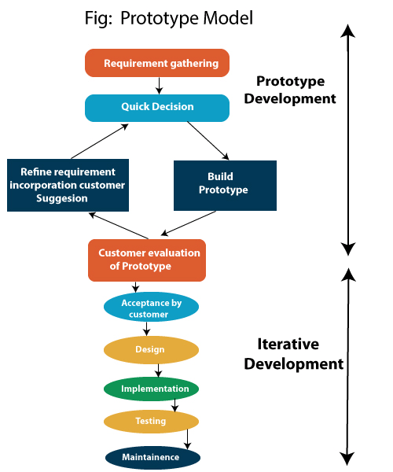

Steps of Prototype Model
- Requirement Gathering and Analyst
- Quick Decision
- Build a Prototype
- Assessment or User Evaluation
- Prototype Refinement
- Engineer Product

Advantage of Prototype Model
- Reduce the risk of incorrect user requirement
- Good where requirement are changing/uncommitted
- Regular visible process aids management
- Support early product marketing
- Reduce Maintenance cost.
- Errors can be detected much earlier as the system is made side by side.

Disadvantage of Prototype Model
- An unstable/badly implemented prototype often becomes the final product.
- Require extensive customer collaboration
  - Costs customer money
  - Needs committed customer
  - Difficult to finish if customer withdraw
  - May be too customer specific, no broad market
- Difficult to know how long the project will last.
- Easy to fall back into the code and fix without proper requirement analysis, design, customer evaluation, and feedback.
- Prototyping tools are expensive.
- Special tools & techniques are required to build a prototype.
- It is a time-consuming process.

